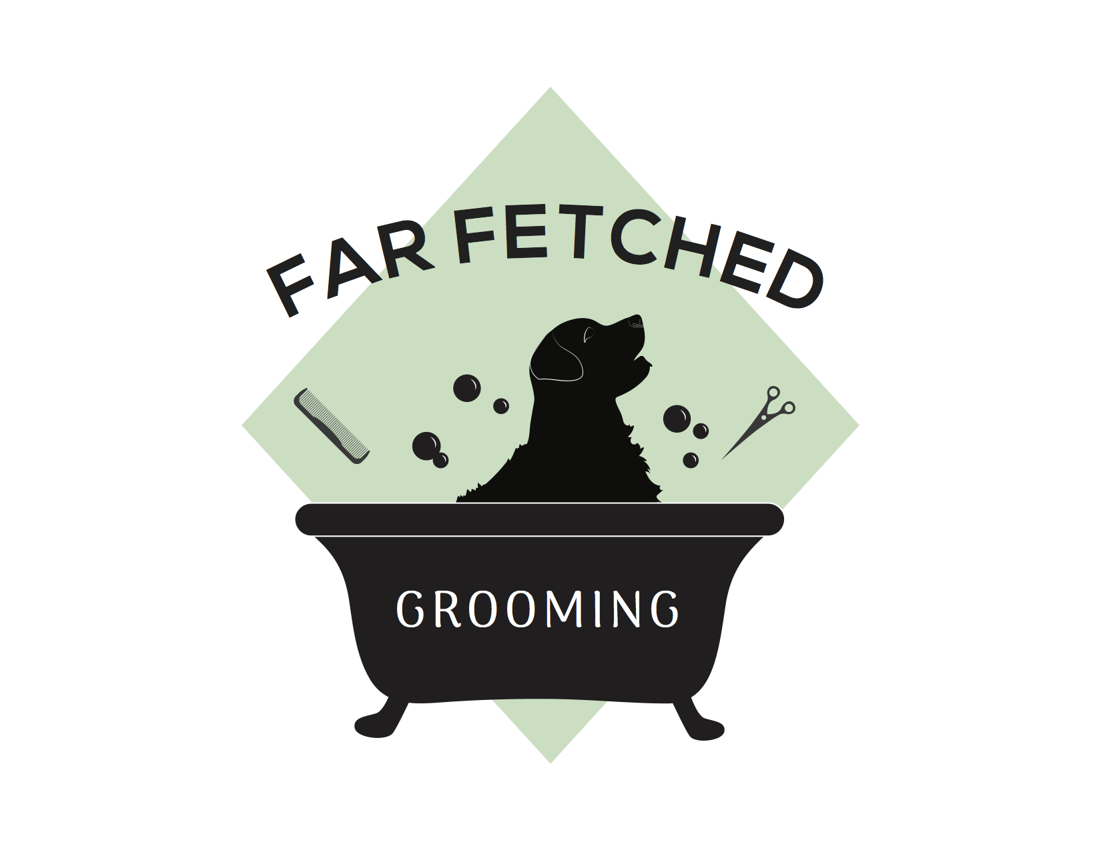
Far Fetched Grooming On Time Pick up Agreement
778-255-0955 farfetchedgrooming@outlook.com

Our salon hours are 9am to 5pm. If provided a specific pick time I, _________________________________ agree to pick up my pet at that time. If late, I agree to call and notify the groomer on shift. I understand that failure to pick up my pet(s) within 30 minutes of the scheduled pick up time will result in boarding charges of $10 on top of the grooming price for every subsequent half an hour following.

I understand that should I result in not picking up my dog by 5pm on the scheduled day of grooming, a boarding fee of $50 per night on top of the compiled fees will result and my dog will have to be picked up the following day at 9am.

I, ________________________________ hold harmless, Jessica Termuende and Danika Hommel of Far Fetched Grooming of any liability following in the result of my failing to pick up my pet on time. I agree to pick up my pet at the specific time or pay for the services rendered as well as any fees incurred.

Owner signature____________________________________date____________________________

Groomer signature_________________________________date_____________________________

