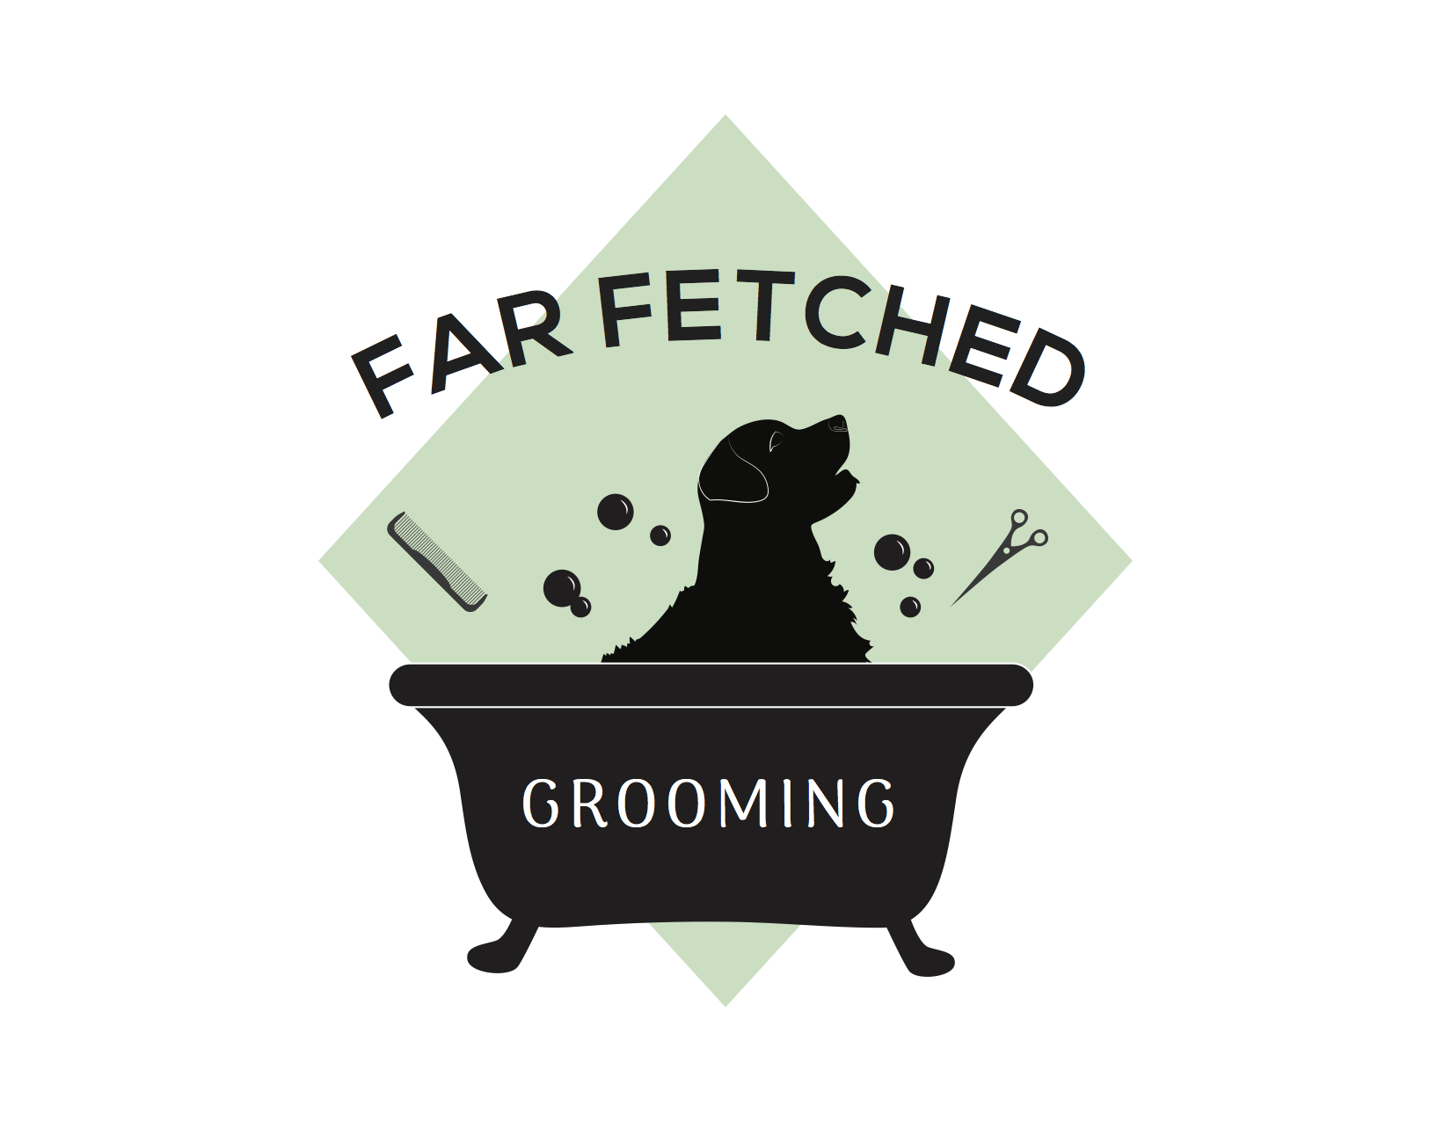
Far Fetched Grooming Matted Pet Release Form

778-255-0955 farfetchedgrooming@outlook.com

If your dog is severely matted it is necessary to remove the matted hair for the comfort and safety of the dog. When a coat becomes tangled beyond the point of being able to be brushed or combed through the most humane way to solve the issue is to shave underneath the matts close to the skin.

Trying to untangle matts is painful and stressful on the dog and the groomer. Matted coats can result in the following issues:

- Skin irritations caused by dirt, dander, trapped water, trapped parasites including ticks and fleas.
- Sores and hair loss; as matts get wound tighter and tighter they eventually pull out of the skin causing bald spots, hot spots and sore skin.

It is quite common to find pre-existing conditions including hot spots, sores, and similar skin conditions once the matts are removed. There is also a chance that your pet’s skin may become irritated from being clipped so close.

Because this process takes extra time, care and precision, there will be additional charges depending on the severity of matting. The base price of the dog’s size plus an additional $15 for every 20 minutes of dematting.

I, _______________________________, hold harmless Jessica Termuende, and Danika Hommel of Far Fetched Grooming from any liability or financial responsibility arising from injury during or directly afterwards as a result of the stripping process in grooming my pet.

___________________________ ________________________________
Owner/Date Groomer

